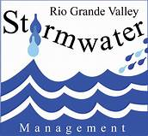
YN
The Dirty Dozen
12 Tips to Prevent
Storm Water Pollution

- Turn off your sprinklers when it rains to avoid water runoff.
- Pick up a bag your pet’s waste! Leaving waste on the ground increases public health risks by allowing harmful bacterial and nutrients to wash into the storm drain and into your local waters.
- Do not apply fertilizers and pesticides before it rains. Contrary to popular belief, the rain will not help soak chemicals into the ground; instead, it creates polluted runoff into your local waters
- Select native or adapted plants & grasses that are drought tolerant and pest resistant; these plants will require less water, fertilizer and pesticides.
- Reduce the amount of paved area and increase the amount of vegetated area in your yard.
- Do not dump your car’s oil on the ground or in the storm drain; dispose of it properly at an oil-recycling center.
- Check your car, boat, or motorcycle for leaks. Clean up spilled fluids with an absorbent material; do not rinse it into the storm drain.
- Compost or mulch your yard waste rather than bagging it, which fills up the landfill, or even worse, sweeping it into the street to get carried in runoff to the storm drain. Excess yard waste in our water depletes oxygen for aquatic life.
- Wash your car with water only or use biodegradable soap to avoid runoff of harmful chemicals and try to wash your car on a lawn or other unpaved surface. To conserve water, use a bucket or hose equipped with a shut-off nozzle. Better yet, use a commercial carwash that recycles its water!
- Dispose of your paint and other household wastes at recycling facilities or events; do not throw excess household chemicals and waste on the street or in the storm drain.
- Do not pump your pool water int the street or drain; pool chemicals can be hazardous to aquatic habitats. Drain your pool into the sanitary sewer system where it can be treated.
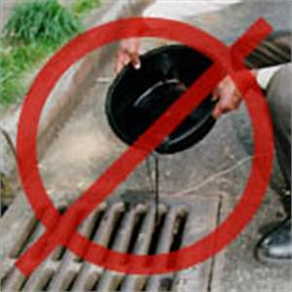 | 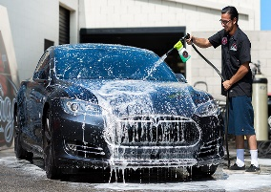 | 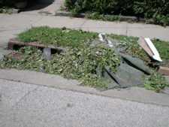 | 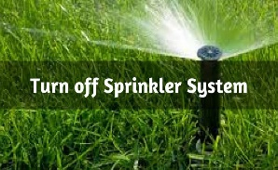 | 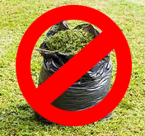
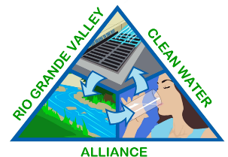 | 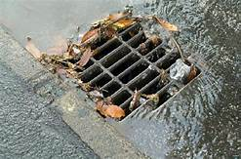 | 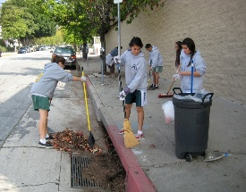 | 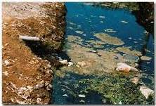
- DON’T MESS WITH TEXAS! Throw your litter in a garbage can & recycle what you can!

