TIPS TO PREVENT STORM WATER POLLUTION
- Turn off your sprinklers when it rains to avoid water runoff.
- Pick up and bag your pet’s waste! Leaving waste on the ground increases public health risks by allowing harmful bacterial and nutrients to wash into the storm drain and into your local waters.
- Select native or adapted plants and grasses that are drought tolerant and pest resistant; these plants will require less water, fertilizer and pesticides.
- Reduce the amount of paved area and increase the amount of vegetated area in your yard.
- Compost or mulch your yard waste rather than bagging it, which fills up the landfill, or even worse, sweeping it into the street to get carried in runoff to the storm drain. Excess yard waste in our water depletes oxygen for aquatic life.
- Dispose of your paint and other household wastes at recycling facilities or events; do not throw excess household chemicals and waste on the street or in the storm drain.
- Do not apply fertilizers and pesticides before it rains. Contrary to popular belief, the rain will not help soak chemicals into the ground; instead, it creates polluted runoff into the local waters.
- Do not dump your car’s oil on the ground or in the storm drain; dispose of it properly at an oil recycling center.
- Check your car, boat or motorcycle for leaks. Clean up spilled fluids with an absorbent material; do not rinse it into the storm drain.
- Wash your car with water only or use biodegradable soap to avoid runoff of harmful chemicals and try to wash your car on a lawn or other unpaved surface. To conserve water, use a bucket or hose equipped with a shut-off nozzle. Better yet, use a commercial carwash that recycles its water!
- Don’t mess with Texas! © Throw your litter in a garbage can and recycle what you can!

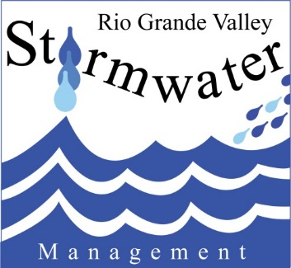

www.cityoflosfresnos.com
www.rgvstormwater.org

For any questions or concerns on our Stormwater program or to report an illicit discharge please call 956-233-5768 or 956-233-4473 after hours.

