2 Lower Laguna Madre Brownsville Ship Chanel Watershed Partnership
Newsletter
Lower Laguna Madre Brownsville Ship Chanel Watershed Partnership May 15, 2020

Next meetings
- May 2021
Steering Committee and Workgroups Meetings
- Stakeholder/Steering Committee Meeting Scheduled for June 17 (Online Venue)- meeting agenda TBD
- A Stakeholder/Steering Committee email listserv has been established to facilitate dissemination of project information.

QAPP, Monitoring and Data Collection
- Development of the Lower Laguna Madre and Brownsville Ship Channel Watershed Protection Plan (WPP) Phase I- Water Quality Monitoring: Field Sampling Readiness Review was developed November 11, 2019. A readiness review meeting led by the LRGVDC-Watershed Coordinator was attended by WPP field staff, including UTRGV faculty and students, on February 4, 2020.
- Prior to the first quarterly sampling event elevations, relative to visual staff gages, of continuous stage height sensors were surveyed at real time hydrologic stations located at Brownsville Public Works (#22120), Cameron County Drainage District 1 Ditch #2 (#22118), and City of Brownsville Land Fill (#22121). The 1st quarterly sampling event was conducted on February 11-12, 202o to collect biased flow data for water quality and instantaneous flow.
- A summary report for the 1st Quarterly Sampling Event with the results were submitted to TCEQ on March 2, 2020 and uploaded to SWQM on April 30.
- Impact of COVID 19 on Project-i.e. 2nd Quarterly Sampling Event, originally scheduled to occur in mid-May 2020 has been delayed in accordance with CDC social distancing guideline. The 2nd has been tentatively rescheduled for mid-June to mid-July. Measures to ensure the safety of field staff will be taken including but not limited to: (a) ensuring that all field personnel are well and fit for duty prior to reporting to field assignments; (b) providing and requiring the use of personal protective equipment; (c) limiting the number of personnel in vehicles; (d) dedicated use of specialized monitoring equipment by single
worker; (e) ensuring personal hygiene supplies are readily to field staff; and (f) ensuring proper disposal of contaminated supplies (e.g. PPE, personal hygiene supplies, sampling
5) Monitoring Timeline:
      - Installation, testing and trial runs:
        - August 2019-Real time hydrologic stations were initially installed
        - August 20, 2019- UTRGV faculty and students attended Acoustic Doppler Current Profiler (ADCP) -Stream Discharge Measurement

Lower Laguna Madre Brownsville Ship Chanel Watershed Partnership May 15, 2020

Newsletter
        - February 2020: In-situ instrumentation including: YSI-EXO2 multi-parameter in-situ sonde and TeledyneRDI StreamPro ADCP were staged in RGV for 1st Quarterly Sampling Event
        - RTHS (Real-Time Hydrological System): Late August 2019.
      - TCEQ pre-monitoring audit and 1st sampling event: Late August 2019

Watershed Characterization Report
In September 2019, TCEQ project manager approved the Water Characterization Report Assessment submitted by UTRGV. The report was developed based on the recommendations of Technical Advisory Committee and includes information on the LLMBSC watershed characterization data gaps for development of the Watershed Protection Plan and strategy to fulfill them.

Grants and funding opportunities
- Texas General Land Office- Coastal Management Program Cycle-26, Pre-proposal due June 10, 2020
- TCEQ Section 319 Nonpoint Source (NPS) Program Fiscal Year 2021 grant solicitation will be posted on June 1st, 2020

Upcoming events
- Stormwater Conference 2020 Canceled
- Stormwater Conference will be rescheduled for May 2021
- 2nd Quarterly biased flow sampling event tentatively scheduled for June-July 2020. Firm date pending status of COVID-19 work/travel restrictions and placement of applicable workplace safeguards in accordance with CDC guidelines.

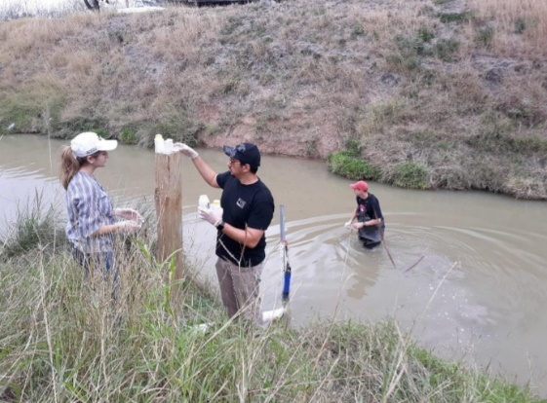

For more information:
https://rgvstormwater.org/llmbsc-watershed-partnership/

