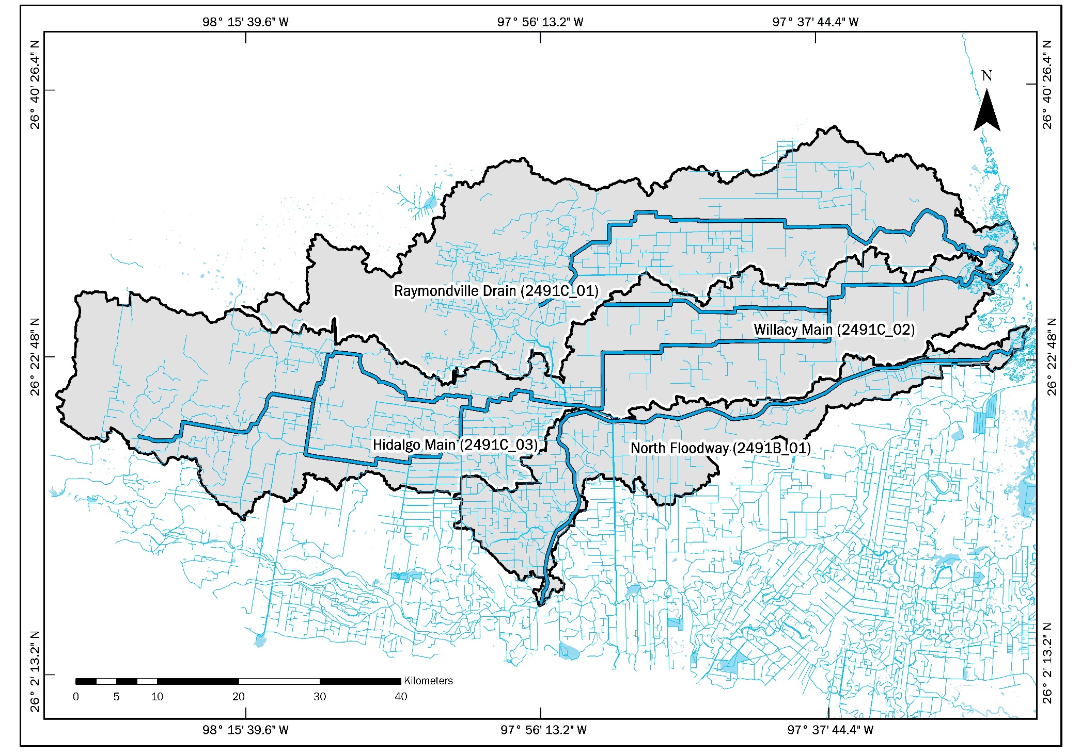
Interim Data Report for the North and Central Watersheds

February 2021

PREPARED IN COOPERATION WITH THE TEXAS COMMISSION ON ENVIRONMENTAL QUALITY AND U.S. ENVIRONMENTAL PROTECTION AGENCY

This project has been funded wholly or in part by the United States Environmental Protection Agency under assistance agreement (582-19-90196) to the Texas Commission on Environmental Quality. The contents of this document do not necessarily reflect the views and policies of the Environmental Protection Agency, nor does the EPA endorse trade names or recommend the use of commercial products mentioned in this document.

Table of Contents

Introduction 2
1. Point Sources 4
2. Nonpoint Sources 6
3. Flow Data 8
3.1 Monthly Flows 10
3.2 Annual Flows 11
4. Water Quality 13
4.1 E. coli 13
4.2 Ammonia 14
4.3 Total Nitrogen 15
4.4 Total Phosphorus 15
4.5 Nitrite and Nitrate 16
4.6 Chlorophyll-a 17
5. Conceptual Model 18
6. Appendix 20

Introduction

The North and Central watersheds are in the southern area of Texas within the Lower Rio Grande Valley (LRGV) region. These watersheds encompass 37% of the area of the well-known South Laguna Madre (LLM) Watershed Hydrologic Unit Code 12110208 (8-digit HUC) (Figure 1). This report contains extensive information to assess and characterize North and Central watersheds located within the LRGV through providing and summarizing the available information related to the point sources (PS), nonpoint sources (NPS), water quality, and flow data for each watershed. PS and NPS data were analyzed to identify the current sources of pollution that may contribute for each watershed. Moreover, the water quality and flow data were analyzed to enable the identification of potential sources of pollution within the North and Central Watersheds. The water quality data incorporated in this report covers three watersheds Hidalgo Willacy Main Drain (HWMD), Raymondville Drain (RVD), and IBWC North Floodway (IBWCNF) watersheds. The report includes also the flow data for the IBWCNF watershed found on the available monitoring stations. While there is no available flow data for either RVD or HWMD,data from state and federal agencies such as: Texas Clean Rivers Program (CRP) and International Boundary and Water Commission (USIBWC) were used to obtain water quality and flow data. Moreover, the elevation raster-files used for the development the watershed delineation, presented a deficiency in the resolution because the region is relatively flat. Therefore, based on the waterway flow the HWMD and RVD watersheds were delineated.

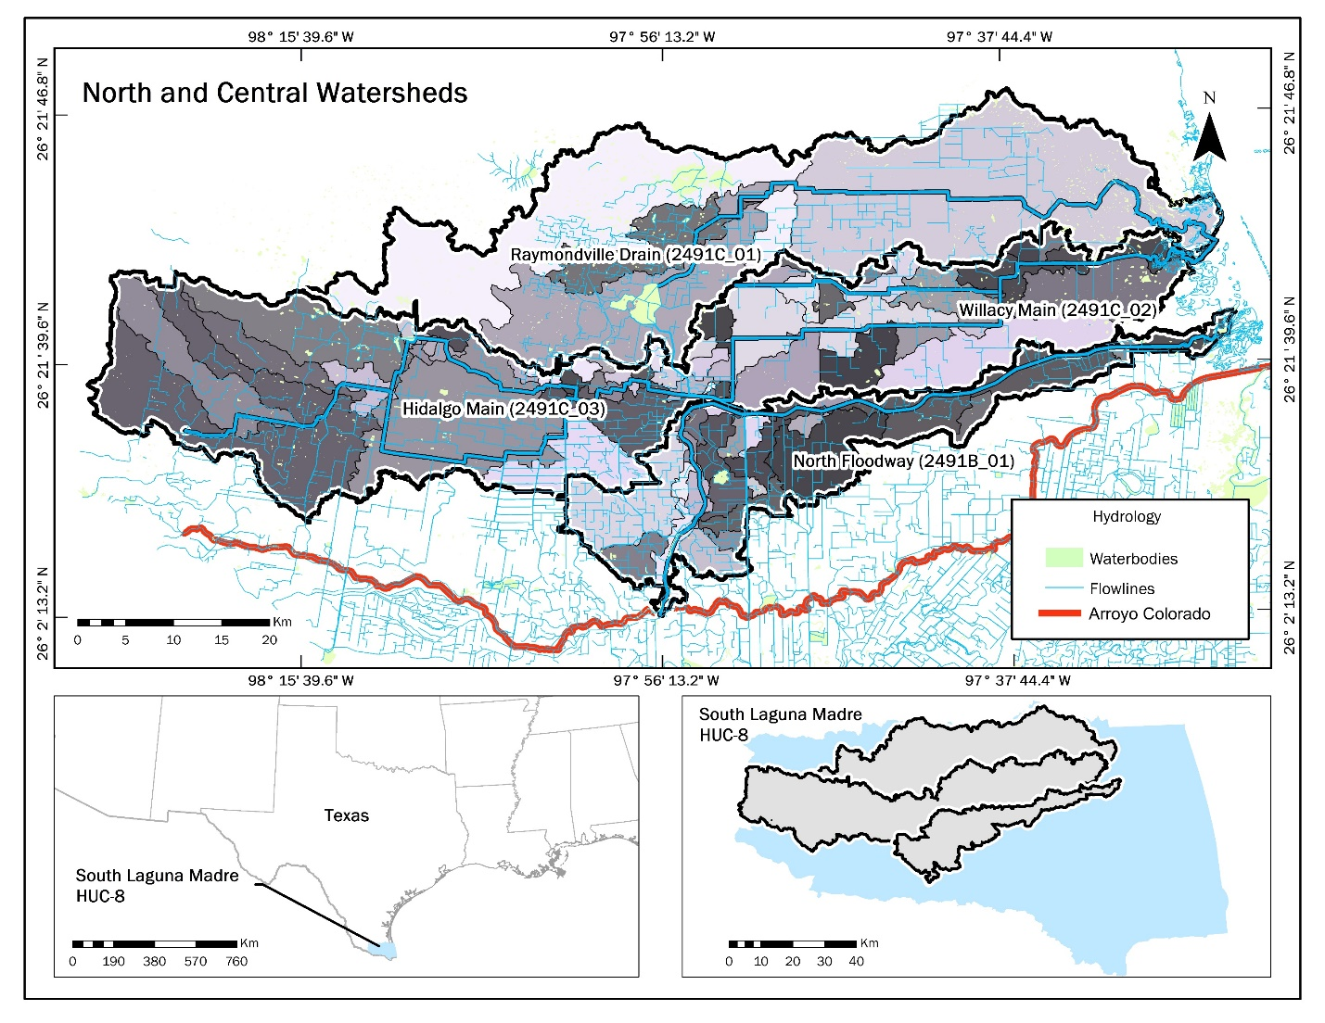Figure 1. North and Central Watersheds

- Point Sources
The point sources of pollution identified in the North and Central Watersheds include permitted wastewater outfalls, landfills, and Texas Land Application Permit (TLAP). The wastewater outfalls and the TLAP locations were obtained from TCEQ website (Figure 2).
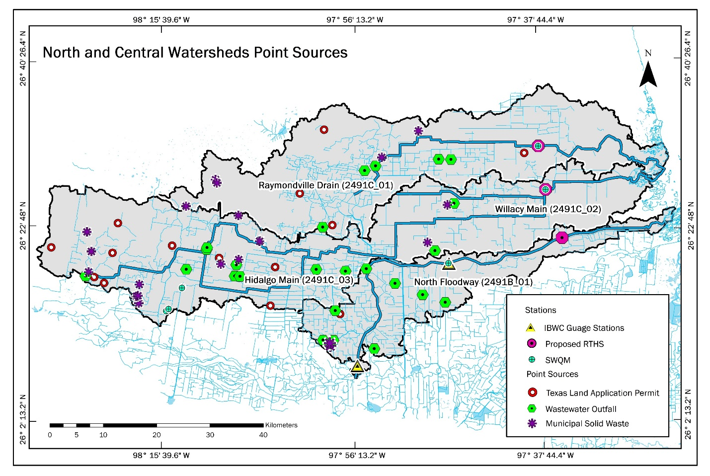Figure 2. North and Central Watersheds Point Sources
These sources are potential contributors to water quality impairments to the North and Central Watersheds. Since the watersheds were currently updated, the point sources of pollution changed throughout the three watersheds. For the HWMD watershed, it shows severe impact by the point sources compared to the other watersheds. Eleven wastewater outfalls discharge their effluent to the HWMD. While there are 5 and 7 wastewater outfalls located within RMD and IBWCNF watersheds; respectively. Most of the wastewater outfalls are the upstream of IBWCNF watershed. Similar to wastewater outfall, the HWMD watershed includes a higher number of municipal solid waste in comparison to the other two watersheds. Overall, the Municipal Solid Waste (MSW) points are more condensed within the upstream of HWMD were more urbanization is found. While there are 3 and 2 MSW located within RMD and IBWCNF watersheds; respectively.
Table 1. Monitoring stations and point source pollution within the North and Central Watersheds
 | Hidalgo Willacy Main Drain | Raymondville Drain | IBWC North Floodway
Stations
IBWC Gauge Stations | 0 | 0 | 2
Proposed RTHS | 1 | 1 | 1
SWQM | 1 | 1 | 1
Point Sources
Texas Land Application Permit | 9 | 4 | 1
Wastewater Outfalls | 11 | 5 | 7
Municipal Solid Waste | 12 | 3 | 2

- Nonpoint Sources
Land cover data were analyzed to determine the relative contributions of NPS in the North and Central Watersheds. In this section, the watershed areas that potentially contribute the most to NPS was identified. Each watershed was analyzed separately for the urbanized areas, cultivated crops, ranches, and Municipal Separate Sewer System (MS4) permits to characterize the different types of NPS within the area.
The main nonpoint sources identified within the watersheds were extracted from the 2016 Land Cover database. Figure 3 represents the relative contribution of each NPS within the three watersheds. Table 2 shows the percentage for each nonpoint source within the three watersheds. HWMD showed to have a greater urbanized area of 10% compared to the other watersheds. This is due to the McAllen-Edinburg- Mission Metropolitan Statistical Area (MSA) is located within the HWMD watershed area. On the other hand, the RVD watershed was determined to have 50% of cultivated crops 2% of urbanized areas. IBWCNF watershed is identified to have the most cultivated crop area with 73% and 7% of urbanized areas. Urban areas and agricultural areas in a watershed are determined to be the main contributors to NPS. It can be concluded that RVD and IBWCNF watersheds can have greater NPS contributions from agricultural sources to the water quality impairment to the Lower Laguna Madre. Generally, this type of land use is located within the downstream tributary areas of the watersheds which ultimately carries significant NPS.

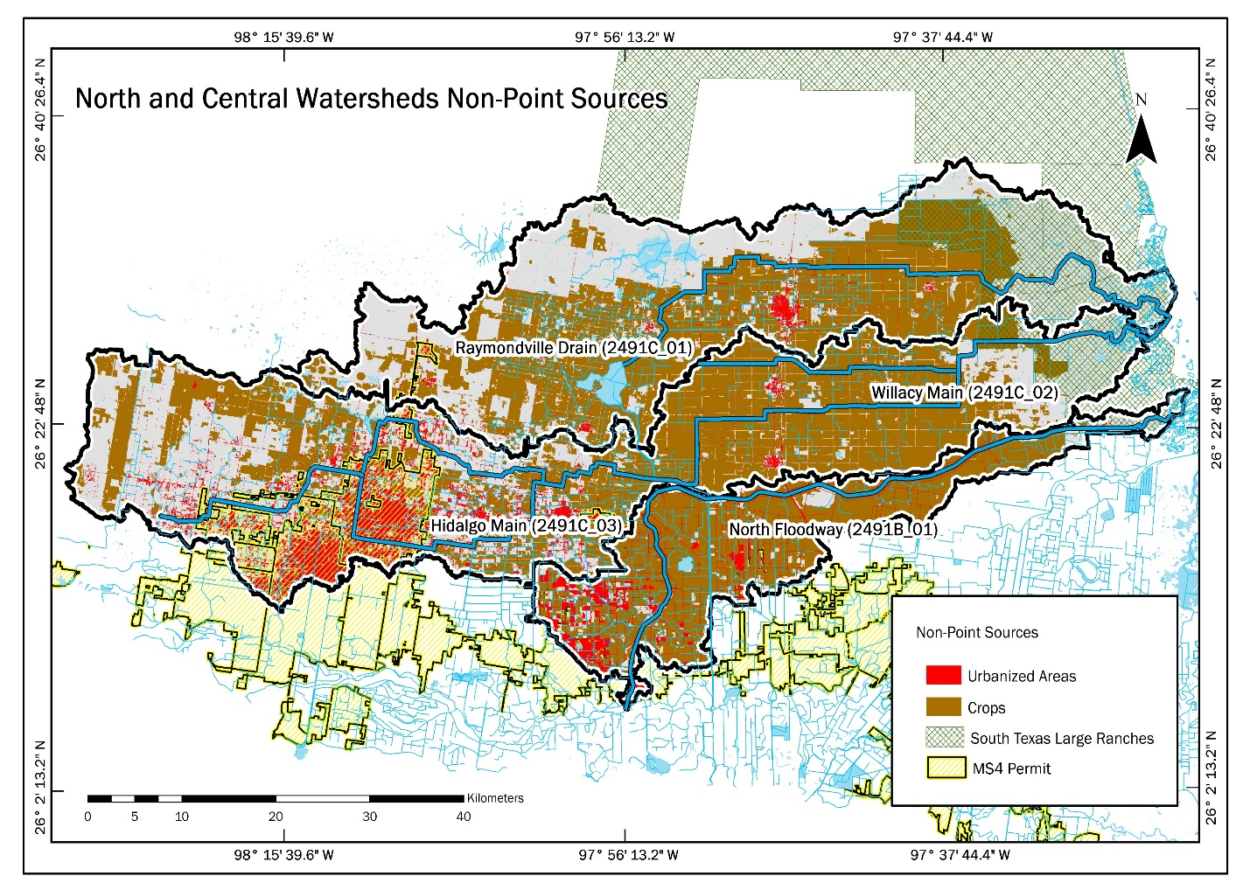Figure 3. Nonpoint sources pollution within the North and Central Watersheds
Table 2. Percentage of the nonpoint sources pollution contributing areas and MS4 permits within the North and Central Watersheds
 | Hidalgo Willacy Main Drain | Raymondville Drain | IBWC North Floodway
Urbanized Areas | 10% | 2% | 7%
Cultivated Crops | 40% | 51% | 73%
South Texas Ranches | 7 % | 16% | 2%
MS4 Permit | Alton | Raymondville | Weslaco
 | Palmhurst | San Perlita | Mercedes
 | McAllen |  | Santa Rosa
 | Edinburg
 | Elsa
 | Edcouch
 | La Villa
 | Lyford

- Flow Data
Currently, there are no monitoring stations installed to measure the flow rate for both HWMD and RVD waterways. However, IBWCNF has two stations available to measure the flow, both stations are managed by USIBWC. The first station is 08470100 North Floodway West of Mercedes (Mercedes). While the second station is 08470200 North Floodway Near Sebastian (Sebastian). The two stations that were found to have available flow data are the stations with 135,542 and 304,982 observations; respectively, from 2012 to 2020.
The Mercedes station is located within the IBWCNF waterway with coordinates of 26° 8′ 58″, -97° 55′ 39″ (WGS 84) and has an elevation of 0.05 m. Tables A.1 through A.4 were used to conduct a statistical analysis. The Mercedes datasets presented values between 2015 to 2020 with a sample size of 140,261 recorded observations. On the other hand, the coordinates of the Sebastian station are 26° 18′ 53″, -97° 46′ 38″ (WGS 84). This station is mainly used as a flood warning station with an elevation of 0.11 m. Tables A.5 to A.8 were used to perform statistical analysis. The Sebastian datasets presented values between 2012 to 2020 with a sample size of 304,982 observations. The sample data recorded in each station consists of flow data in cubic meter per second (CMS) recorded every 15 minutes. Boxplots were created using R studio for annual and monthly flow values. The outliers from the boxplots were neglected to have a better representation of the sample distribution. The big storm events were not shown in the boxplots since the outliers were neglected.

Table 3. Summary of the monthly flow data for the two monitoring stations located on the USIBWC floodway
 | West Mercedes |  |  |  | Near Sebastian
Data Range | 135, 542 |  |  |  | 304, 977
Month | Mean | Min | Max | Median | Mean | Min | Max | Median
January | 2.27 | 0.00 | 6.26 | 2.35 | 2.41 | 0.46 | 16.74 | 1.83
February | 0.70 | 0.00 | 6.01 | 0.21 | 2.67 | 0.47 | 10.15 | 1.99
March | 0.86 | 0.00 | 89.49 | 0.10 | 2.85 | 0.41 | 235.52 | 1.49
April | 2.28 | 0.00 | 44.25 | 0.22 | 3.23 | 0.44 | 17.23 | 2.63
May | 1.17 | 0.00 | 8.23 | 0.39 | 4.03 | 0.59 | 135.42 | 2.93
June | 21.86 | 0.00 | 1187.66 | 5.17 | 14.17 | 0.00 | 3852.96 | 2.47
July | 3.30 | 0.00 | 15.21 | 1.67 | 28.32 | 0.00 | 8412.59 | 1.90
August | 0.36 | 0.00 | 2.34 | 0.31 | 3.87 | 0.00 | 29.47 | 2.06
September | 0.36 | 0.00 | 4.42 | 0.04 | 2.55 | 0.36 | 16.26 | 1.82
October | 7.76 | 0.00 | 66.53 | 0.98 | 2.57 | 0.24 | 50.06 | 1.21
November | 0.21 | 0.07 | 0.63 | 0.12 | 1.31 | 0.18 | 29.27 | 0.68
December | 0.00 | 0.00 | 0.00 | 0.00 | 1.08 | 0.20 | 9.23 | 0.73
St. Dev. | 15.58 |  |  |  | 127.19
Source: USIBWC website
Table 4. Summary of the annual flow data for the two monitoring stations located on the USIBWC floodway
 | West Mercedes |  |  |  | Near Sebastian
Year | Mean | Min | Max | Median | Mean | Min | Max | Median
2012 | 0 | 0 | 0 | 0 | 1.85 | 0.57 | 8.84 | 1.79
2013 | 0 | 0 | 0 | 0 | 1.64 | 0.58 | 11.96 | 1.33
2014 | 0 | 0 | 0 | 0 | 2.4 | 0.55 | 10.33 | 1.82
2015 | 10.72 | 0 | 66.53 | 0.96 | 4.07 | 0.3 | 135.42 | 2.2
2016 | 1.83 | 0 | 29.49 | 0.15 | 2.06 | 0.18 | 14.62 | 1.27
2017 | 19.29 | 0 | 1187.66 | 2.41 | 3.75 | 0.32 | 235.52 | 3.63
2018 | 4.16 | 0 | 424.28 | 0.77 | 10.51 | 0 | 3852.96 | 1.86
2019 | 3.3 | 0 | 15.21 | 1.67 | 2.85 | 0 | 164.63 | 1.13
2020 | 10.72 | 0 | 66.53 | 0.96 | 27.62 | 0 | 8412.59 | 2.89
Source: USIBWC website
Figure 4 shows two hydrographs of the main flooding events that hit the valley for the past two years in June 2018 and July 2020. There is a significant flow increase from both stations. However, Sebastian station showed substantially higher flow than Mercedes station for both events. The maximum recorded flow in Sebastian station was 3765 CMS in June 2018, while in July 2020 exceeded 8000 CMS. Mercedes station showed only high flow in the 2018 event, the maximum recorded flow was 1187 CMS. However, the flow in the Mercedes station in the 2020 flooding event was negligible, the maximum recorded flow was 15 CMS. It is worth noting that both the value of precipitation in both events was close; the estimated value is 15 inches.
Figure 4: Hydrographs of the monitoring stations on the USIBWC floodway showing the flow rate in the two main flooding events in 2018 and 2020.

3.1 Monthly Flows
The monthly flow was assessed by developing boxplots with the same dataset as well as for the annual flow results. Figure 5 shows box and whisker plots of the flow for the two monitoring stations. The three months of June, July, and October were found to have higher flow variance since storm events are more frequent to occur. On the other hand, February, March, August, September, and November are found to have consistent flow values close to zero CMS. June is the month with almost 50% higher flow values compared to the other months.
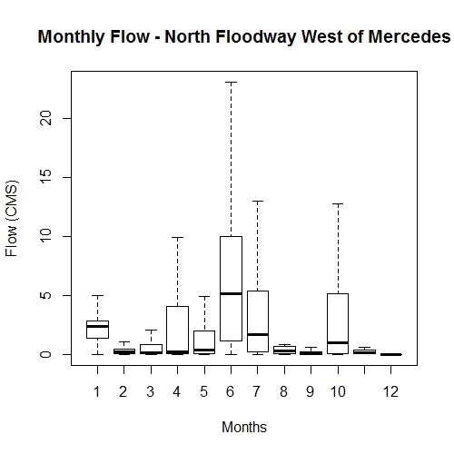
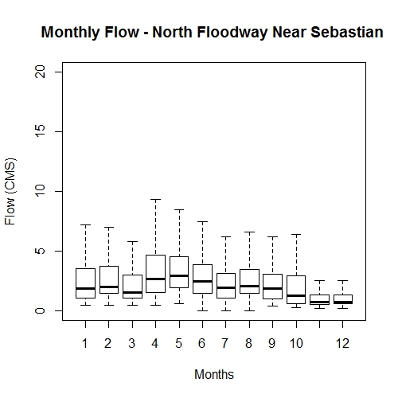
Figure 5: Boxplot of the monthly flow for USIBW flow monitoring station at Mercedes and Sebastian, the large box represents the 25th percentile, median, and 75th percentile; the whiskers represent the 5th and 95th percentiles.
A
B

3.2 Annual Flows
Figure 6 shows a boxplot for the annual flow of the Mercedes station from 2015 to 2020 to show the data distribution of the recorded flow. In 2015, the annual mean flow varies much less than in 2018 and 2020. In 2017, the annual mean flow is the lowest among the other years and the small size of the box corresponds to a high correlation between values. In 2018, the large box indicates that there were a wide variety of flow values, especially at higher levels. Moreover, in 2019 the annual flow values presented the same mean as in 2015 which is close to 0 CMS and the overall flow values were close to each other. These boxplots show that the years 2015, 2018, and 2020 showed a high variety of flow values which correspond to sudden rainfall events. The total maximum flow value was recorded in June 2018 with 1187.7 CMS.
Figure 6 shows the distribution of the Sebastian sample data. In 2012, the annual flow values were relatively consistent but not more than the flow values in 2013. Also, in 2012, 2014 and 2019 25% of the flow values were close to each other. The mean flow value for 2012 and 2014 close as well. From 2015 to 2018, 25% of the annual flow values had higher values. Overall, the mean values for all the years were near 2 CMS.
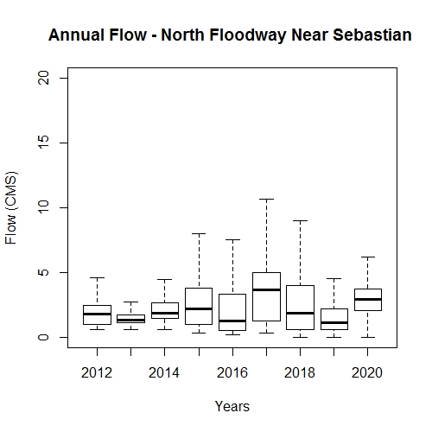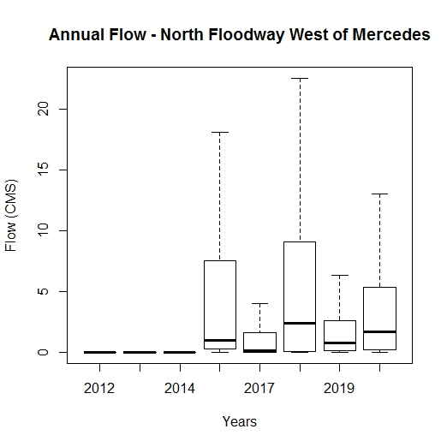Figure 6. Boxplot of the annual flow for USIBW flow monitoring station at Mercedes and Sebastian, the large box represents the 25th percentile, median, and 75th percentile; the whiskers represent the 5th and 95th percentiles.
A
B

- Water Quality
There was water quality data acquired for the three watersheds. HWMD and RVD water quality data was obtained by the Clean Rivers Program with only 8 samples available. For the IBWC North Floodway, the data was extracted from SWQMs with 29 samples.
Table 5. North and Central Water Quality Summaries
 |  | Bacteria MPN/100ML | Ammonia MG/L AS N | TKN (Total Nitrogen) MG/L AS N | TP (Total Phosphorus) MG/L AS P | Nitrite +Nitrate  MG/L AS N | Chlorophyll-a UG/L
Hidalgo Willacy Main Drain  [8 samples] | Mean | 558.9 | 0.1 | 2.0 | 0.6 | 3.5 | 43.8
 | Max | 2200.0 | 0.3 | 3.6 | 0.8 | 5.7 | 98.5
 | Min | 10.0 | 0.0 | 1.0 | 0.2 | 0.0 | 13.5
 | Median | 100.0 | 0.2 | 1.8 | 0.7 | 3.9 | 25.5
 | SD | 819.03 | 0.10 | 0.90 | 0.25 | 2.05 | 34.31
Raymondville  Drain  [8 Samples] | Mean | 845.5 | 0.1 | 1.7 | 0.2 | 1.9 | 28.7
 | Max | 2400.0 | 0.2 | 3.1 | 0.4 | 5.7 | 67.0
 | Min | 74.0 | 0.0 | 0.4 | 0.1 | 0.6 | 3.8
 | Median | 185.0 | 0.1 | 1.5 | 0.2 | 1.5 | 26.6
 | SD | 986.37 | 0.08 | 0.88 | 0.10 | 1.64 | 19.90
IBWC North Floodway  [25 Samples] | Mean | 504.7 | 0.1 | 1.3 | 0.3 | 3.2 | 39.9
 | Max | 7300.0 | 0.3 | 3.2 | 0.6 | 6.7 | 82.3
 | Min | 0.0 | 0.0 | 0.0 | 0.0 | 0.0 | 2.3
 | Median | 96.0 | 0.1 | 1.4 | 0.3 | 3.0 | 36.3
 | SD | 1374.24 | 0.07 | 0.72 | 0.15 | 1.40 | 23.08
Screening Level |  | 126 | 0.33 | 1.0 | 0.69 | - | 14.10
Source: Clean Rivers Program and SWQMs

4.1 E. coli
The E. coli levels for all the watersheds are mostly higher than the action level at 126 MPN/100ML. RVD show to have the highest levels compared to the other watersheds which can maybe occurred due to septic tank leakage, sewage overflow, poorly structured sewage systems, and polluted stormwater runoff.

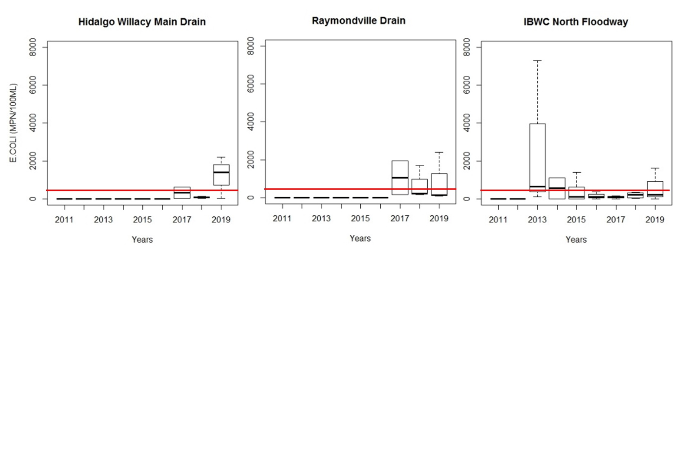Figure 7. Bacteria levels for the North and Central Watersheds.
4.2 Ammonia
Ammonia levels for all three watersheds were below the action level of 0.33 MG/L. According to the U.S. Environmental Protection Agency (EPA), the watersheds could be affected by the level of decomposition of organic matter and some fertilizers used in agriculture. The mean values for the overall watersheds is 0.1 MG/L
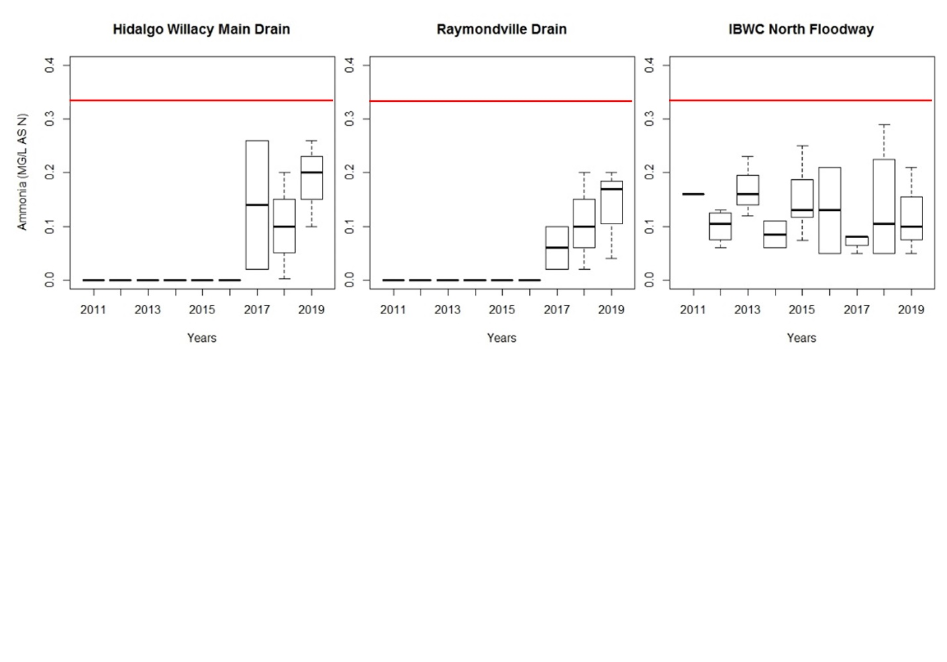Figure 8. Ammonia levels for the North and Central Watersheds

4.3 Total Nitrogen
Total Nitrogen levels mainly exceeded the action level in the three North and Central Watersheds. 2018 levels were the highest compared to the other years with more than 3.0 MG/L levels of total nitrogen. The presence of total nitrogen in HWMD, RVD, and IBWCNF, according to EPA, are sources of failing septic systems, croplands, and industrial discharges (Reference).
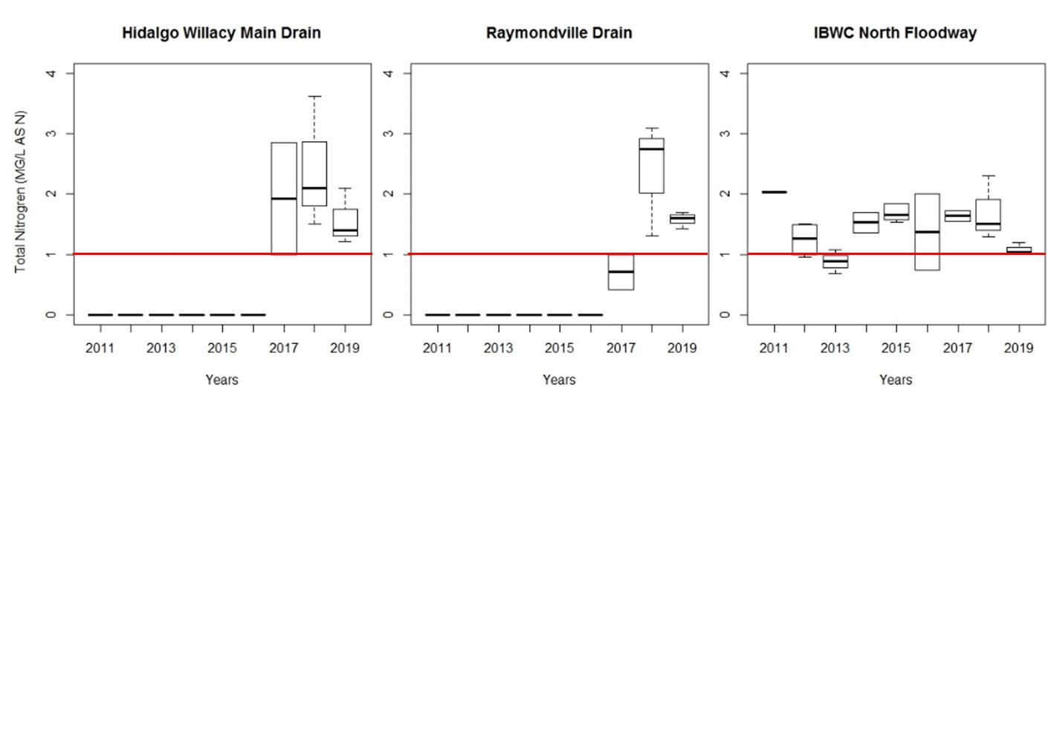
Figure 9. Total Nitrogen levels for the North and Central Watersheds.
4.4 Total Phosphorus
Total phosphorus levels didn`t exceed the action level values in all North and Central watersheds; the action level should be less than 0.69 MG/L. According to USGS, soil erosion is the main source of total phosphorus during flooding events that can be the potential source of high levels of total phosphorus in these watersheds (Reference). However, since there were two only main flooding events in the last five years; phosphorus levels remain within the normal range.

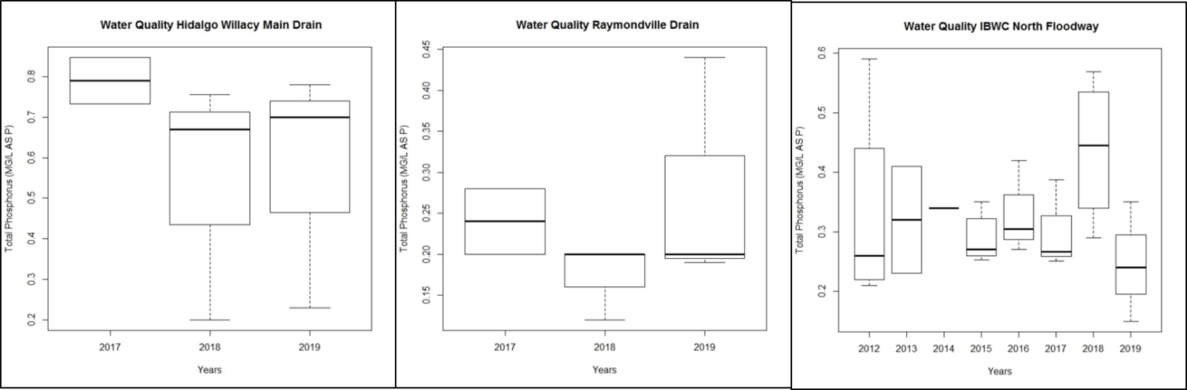
Figure 10. Total Phosphorus levels for the North and Central Watersheds.
4.5 Nitrite and Nitrate
The nitrite and nitrate levels for the North and Central watersheds show to be higher for all the years from 2012 to 2020. This may be to the large agricultural land located within three watersheds which can discharge chemical fertilizers to the waterways.
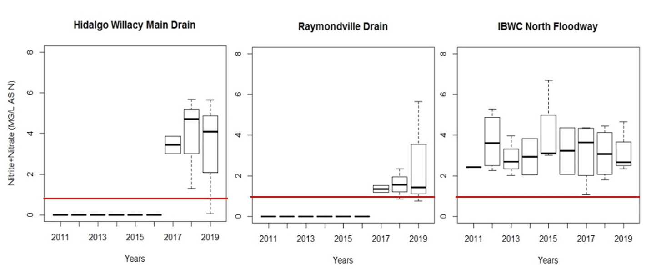
Figure 11. Nitrite and Nitrate levels for the North and Central Watersheds.

4.6 Chlorophyll-a
Chlorophyll-a levels are relatively high in all watersheds suggesting the presence of excess amounts of algae. In 2018, HWMD had the highest levels of Chlorophyll-a of 100 uG/L. Generally, the mean values for Chlorophyll-a range from 20 uG/L to 70 uG/L.
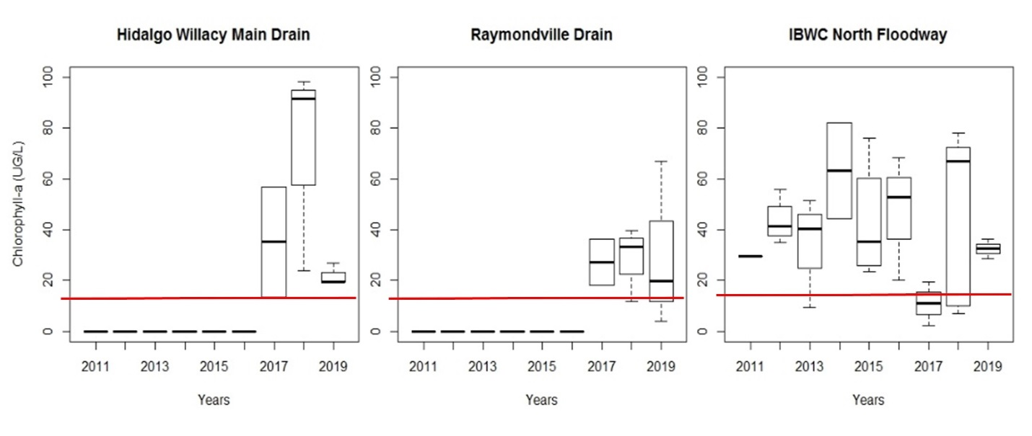
Figure 12. Chlorophyll-a levels for the North and Central Watersheds.

- Conceptual Model
Due to the flat surface in the North and Central watersheds plain, the man-made waterways affect the entire flowline network, which in turn drives the water quality conceptual model. Previous watershed delineation of the north and central watersheds showed some overlapping waterways with other watersheds. Therefore, some improvements were conducted to demonstrate an accurate representation of the watersheds. The addition of pour points to the areas where the overlapping occurred facilitated the improvement for the watershed delineation. The watershed delineation methodology consisted of utilizing Hydrology tools through ArcGIS. The hydrology tools encompassed the generation elevation-raster files such as, fill, flow direction, and flow accumulation. Furthermore, the flow accumulation was used to add the pour points to the areas with greater cell concentration. The HWMD watershed had several small subbasins towards the RVD watershed which correspond to the addition of new pour points because the HWMD waterway overlapped with the RVD watershed. The IBWCNF watershed was improved by neglecting the subbasins that were overlapping with the Arroyo Colorado watershed. To conclude, the LIDAR 2018 elevation data available used in this watershed delineation is not sufficient to represent an accurate drainage area for the North and Central Watersheds. The input of stakeholders within the jurisdiction of the watersheds as well as engineering judgment is crucial for an accurate watershed delineation process.
For instance, Willacy Canal is a lateral drain that potentially drains into the IBWCNF watershed. USGS viewer map used to identify the direction of the flow of the canal which figure 13 shows on the lower-left how the flow direction is not going to one direction. Consequently, the aggregation of new sub-basins was added to the overall IBWCNF drainage area.

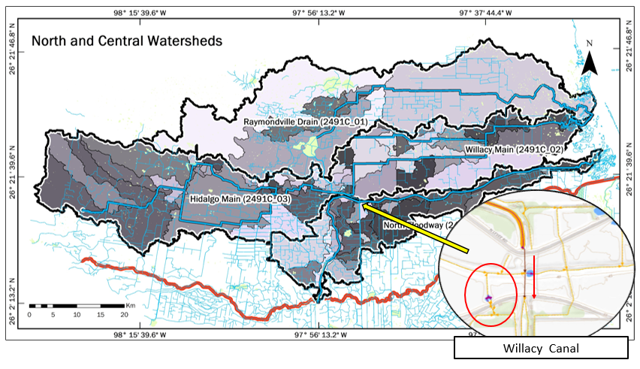Figure 13. North and Central Watershed delineation improvements highlighting the addition of several subbasins that Willacy Canal potentially drains to.

- Appendix

Table A.1. Hidalgo Willacy Main Drain Wastewater Outfalls
Hidalgo Willacy Main Drain
 | PERMIT NUM | PERMITTEE
1 | 13523-014 | LA JOYA ISD
2 | 04040-000 | CALPINE CONSTRUCTION FINANCE CO LP & CALPINE OPERATING SERVICES CO INC
3 | 10503-002 | CITY OF EDINBURG
4 | 04138-000 | CALPINE HIDALGO ENERGY CEN; CALPINE OP SERV CO; BROWNSVILLE PUB
5 | 10503-002 | CITY OF EDINBURG
6 | 10633-004 | CITY OF MCALLEN
7 | 13742-001 | SEBASTIAN MUD
8 | 11510-002 | CITY OF ELSA
9 | 04782-000 | NORTH ALAMO WSC
10 | 14919-001 | CITY OF EDCOUCH
11 | 00847719 | CITY OF LYFORD

Table A.2. Raymondville Drain Wastewater Outfalls
Raymondville Drain
 | PERMIT NUM | PERMITTEE
1 | 04480-000 | NORTH ALAMO WSC
2 | 13747-001 | NORTH ALAMO WSC
3 | 13747-004 | NORTH ALAMO WSC
4 | 10365-001 | CITY OF RAYMONDVILLE
5 | 05251-000 | CITY OF RAYMONDVILLE

Table A.3. IBWC North Floodway Wastewater Outfalls
IBWC North Floodway
 | PERMIT NUM | PERMITTEE
1 | 10619-001 | CITY OF WESLACO
2 | 10619-003 | CITY OF WESLACO
3 | 10330-001 | CITY OF SANTA ROSA
4 | 15513-001 | NORTH ALAMO WSC
5 | 14781-002 | CITY OF LA VILLA
6 | 04758-000 | PEN JOINT TENANTS AND NORTH CAMERON RWSC
7 | 01752-000 | RIO GRANDE VALLEY SUGAR GROWERS INC

Table A.4. Hidalgo Willacy Main Drain Wastewater Landfills
Hidalgo Willacy Main Drain
 | NAME | FACILITY
1 | CITY OF MCALLEN LANDFILL | POST CLOSED
2 | HIDALGO COUNTY SHREDDER--GRINDER FACILITY | NOT CONSTRUCTED
3 | HIDALGO COUNTY | CLOSED
4 | CITY OF MISSION LANDFILL | CLOSED
5 | CITY OF WESLACO LANDFILL | INACTIVE
6 | WILLACY COUNTY LANDFILL | POST CLOSED
7 | GREASE SPECIALIST LIQUID WASTE PROCESSING FACILITY | NOT CONSTRUCTED
8 | CITY OF MCALLEN | NOT CONSTRUCTED
9 | HIDALGO COUNTY LANDFILL | INACTIVE
10 | RUBENS VACUUM & HYDROJETTING LIQUID WASTE PROCESSING FACILITY | INACTIVE
11 | MLB EDINBURG LIQUID TRANSFER STATION | INACTIVE
12 | CITY OF EDINBURG | CLOSED
13 | CITY OF LYFORD LANDFILL | CLOSED

Table A.5. Raymondville Drain Wastewater Landfills
Raymondville Drain
 | NAME | FACILITY
1 | HIDALGO COUNTY | NOT CONSTRUCTED
2 | WILLACY COUNTY SOLID WASTE LANDFILL | NOT CONSTRUCTED
3 | RECYCLING CONSULTANT SERCVICES | ACTIVE
4 | UNION Y DIGNIDAD LANDFILL | CLOSED
5 | CITY OF EDINBURG LANDFILL | NOT CONSTRUCTED
6 | CITY OF MERCEDES TRANSFER STATION FACILITY | NOT CONSTRUCTED
7 | CITY OF EDINBURG LANDFILL | ACTIVE
8 | CITY OF RAYMONDVILLE LANDFILL | POST CLOSED

Table A.6. IBWC North Floodway Wastewater Landfills
IBWC North Floodway
 | NAME | FACILITY
1 | CITY OF WESLACO LANDFILL | CLOSED

Table A.7. Mercedes Annual Mean Dataset
IBWCNF Mercedes Annual Mean Flow Data
Date | CMS
1/1/2015 | 0.379763321
1/1/2016 | 0
1/1/2017 | 0.277815597
1/1/2018 | 2.453020878
1/1/2019 | 1.221470144
1/1/2020 | 0.008724787

Table A.8. Mercedes annual max flow for USIBWC monitoring station
IBWCNF Mercedes Annual Max Flow Data
Date | CMS
1/1/2015 | 66.532
1/1/2016 | 0
1/1/2017 | 29.488
1/1/2018 | 1187.659
1/1/2019 | 424.28
1/1/2020 | 15.212

Table A.9. Mercedes Monthly Mean Dataset
IBWCNF Mercedes Monthly Mean Flow Data
Date | CMS
4/1/2015 | 0.000003
8/1/2015 | 0.036335
10/1/2015 | 4.431523
11/1/2015 | 0.015832
9/1/2017 | 0.050864
10/1/2017 | 0.730040
3/1/2018 | 0.295422
4/1/2018 | 0.000121
5/1/2018 | 0.000003
6/1/2018 | 25.457163
9/1/2018 | 0.000606
10/1/2018 | 0.081366
1/1/2019 | 0.783847
2/1/2019 | 0.433344
3/1/2019 | 0.269581
4/1/2019 | 1.506642
5/1/2019 | 0.978656
6/1/2019 | 10.869474
8/1/2019 | 0.000786
9/1/2019 | 0.000305
7/1/2020 | 0.078638

Table A.10. Mercedes Monthly Max Dataset
IBWCNF Mercedes Monthly Max Flow Data
Date | CMS
4/1/2015 | 0.001
8/1/2015 | 0.798
10/1/2015 | 66.532
11/1/2015 | 0.626
9/1/2017 | 4.416
10/1/2017 | 29.488
3/1/2018 | 89.488
4/1/2018 | 0.006
5/1/2018 | 0.005
6/1/2018 | 1187.659
9/1/2018 | 0.143
10/1/2018 | 9.03
1/1/2019 | 6.262
2/1/2019 | 6.01
3/1/2019 | 22.102
4/1/2019 | 44.249
5/1/2019 | 8.226
6/1/2019 | 424.28
8/1/2019 | 2.34
9/1/2019 | 0.878
7/1/2020 | 15.212

Table A.11. Sebastian Annual Mean Dataset
IBWCNF Sebastian Annual Mean Flow Data
Date | CMS
1/1/2012 | 1.853545709
1/1/2013 | 1.64018472
1/1/2014 | 2.404222475
1/1/2015 | 4.071965205
1/1/2016 | 2.059347752
1/1/2017 | 3.749904318
1/1/2018 | 10.50905489
1/1/2019 | 2.853023695

Table A.12. Sebastian Annual Max Dataset
IBWCNF Sebastian Annual Max Flow Data
Date | CMS
1/1/2012 | 8.841
1/1/2013 | 11.962
1/1/2014 | 10.33
1/1/2015 | 135.421
1/1/2016 | 14.623
1/1/2017 | 235.523
1/1/2018 | 3852.955
1/1/2019 | 164.628
 | 8412.59

Table A.13. Sebastian Monthly Max Dataset
IBWCNF Sebastian Monthly Max Flow Data
Date | CMS
1/1/2012 | 4.093
2/1/2012 | 4.859
3/1/2012 | 8.841
4/1/2012 | 4.857
5/1/2012 | 4.979
6/1/2012 | 3.183
7/1/2012 | 3.692
8/1/2012 | 2.797
9/1/2012 | 2.806
10/1/2012 | 5.353
11/1/2012 | 1.003
12/1/2012 | 0.859
1/1/2013 | 1.541
2/1/2013 | 1.953
3/1/2013 | 1.216
4/1/2013 | 5.16
5/1/2013 | 7.988
6/1/2013 | 3.614
7/1/2013 | 2.979
8/1/2013 | 3.635
9/1/2013 | 7.617
10/1/2013 | 2.462
11/1/2013 | 11.962
12/1/2013 | 6.541
1/1/2014 | 6.541
2/1/2014 | 2.026
3/1/2014 | 2.5
4/1/2014 | 3
5/1/2014 | 4.445
6/1/2014 | 3.453
7/1/2014 | 3.299
8/1/2014 | 5.102
9/1/2014 | 10.33
10/1/2014 | 6.541
11/1/2014 | 9.956
12/1/2014 | 9.228
1/1/2015 | 16.741
2/1/2015 | 4.027
3/1/2015 | 16.855
4/1/2015 | 17.228
5/1/2015 | 135.421
6/1/2015 | 18.09
7/1/2015 | 6.112
8/1/2015 | 27.069
9/1/2015 | 16.259
10/1/2015 | 50.058
11/1/2015 | 29.267
12/1/2015 | 1.971
1/1/2016 | 4.034
2/1/2016 | 4.29
3/1/2016 | 12.807
4/1/2016 | 6.515
5/1/2016 | 13.217
6/1/2016 | 11.712
7/1/2016 | 4.686
8/1/2016 | 14.623
9/1/2016 | 9.532
10/1/2016 | 0.6
11/1/2016 | 4.368
12/1/2016 | 2.626
1/1/2017 | 10.762
2/1/2017 | 7.562
3/1/2017 | 235.523
4/1/2017 | 8.733
5/1/2017 | 16.443
6/1/2017 | 8.99
7/1/2017 | 8.558
8/1/2017 | 7.266
9/1/2017 | 6.902
10/1/2017 | 8.25
11/1/2017 | 4.489
12/1/2017 | 3.309
1/1/2018 | 5.688
2/1/2018 | 10.149
3/1/2018 | 5.963
4/1/2018 | 7.78
5/1/2018 | 6.463
6/1/2018 | 3852.955
7/1/2018 | 4.167
8/1/2018 | 3.714
9/1/2018 | 15.017
10/1/2018 | 3.115
11/1/2018 | 0.824
12/1/2018 | 1.56
1/1/2019 | 6.512
2/1/2019 | 6.54
3/1/2019 | 5.504
4/1/2019 | 7.953
5/1/2019 | 4.164
6/1/2019 | 164.628
7/1/2019 | 33.66
8/1/2019 | 10.458
9/1/2019 | 7.996
10/1/2019 | 4.408
11/1/2019 | 6.242
12/1/2019 | 3.502
1/1/2020 | 3.782
2/1/2020 | 4.545
3/1/2020 | 5.912
4/1/2020 | 5.584
5/1/2020 | 7.92
6/1/2020 | 19.576
7/1/2020 | 8412.59
8/1/2020 | 29.472
9/1/2020 | 2.894
10/1/2020 | 2.894
11/1/2020 | 2.894

Table A.14: Sebastian Monthly Mean Dataset
IBWCNF Sebastian Monthly Mean Flow Data
Date | CMS
1/1/2012 | 2.02740289
2/1/2012 | 3.020897731
3/1/2012 | 1.76131588
4/1/2012 | 1.961717976
5/1/2012 | 2.689133108
6/1/2012 | 2.556851513
7/1/2012 | 2.275675237
8/1/2012 | 2.084891574
9/1/2012 | 1.50170625
10/1/2012 | 1.033675101
11/1/2012 | 0.736692254
12/1/2012 | 0.663114353
1/1/2013 | 0.839900571
2/1/2013 | 1.483316865
3/1/2013 | 0.893158532
4/1/2013 | 1.683935664
5/1/2013 | 1.885742945
6/1/2013 | 1.461047454
7/1/2013 | 1.343491743
8/1/2013 | 1.441226178
9/1/2013 | 3.018519834
10/1/2013 | 1.837949849
11/1/2013 | 2.196181252
12/1/2013 | 1.630258517
1/1/2014 | 2.420097301
2/1/2014 | 1.568461027
3/1/2014 | 1.412319533
4/1/2014 | 1.853850312
5/1/2014 | 2.589646309
6/1/2014 | 2.135571776
7/1/2014 | 1.904715729
8/1/2014 | 1.750061348
9/1/2014 | 5.046942957
10/1/2014 | 3.63469886
11/1/2014 | 2.474148907
12/1/2014 | 2.05501914
1/1/2015 | 2.34797379
2/1/2015 | 2.352173363
3/1/2015 | 5.550554772
4/1/2015 | 3.915702224
5/1/2015 | 10.12663138
6/1/2015 | 3.805440319
7/1/2015 | 2.352503024
8/1/2015 | 3.87776967
9/1/2015 | 2.4554125
10/1/2015 | 8.663968425
11/1/2015 | 2.075866435
12/1/2015 | 1.038026546
1/1/2016 | 0.988954637
2/1/2016 | 1.767099497
3/1/2016 | 1.687740255
4/1/2016 | 3.444958333
5/1/2016 | 4.20462836
6/1/2016 | 3.186446181
7/1/2016 | 2.82556922
8/1/2016 | 3.366549059
9/1/2016 | 1.769836572
10/1/2016 | 0.390949933
11/1/2016 | 0.444636364
12/1/2016 | 0.636858199
1/1/2017 | 2.767975806
2/1/2017 | 3.153190458
3/1/2017 | 7.860833725
4/1/2017 | 5.761921181
5/1/2017 | 5.754701826
6/1/2017 | 4.447475694
7/1/2017 | 5.371573554
8/1/2017 | 4.300611523
9/1/2017 | 1.868826761
10/1/2017 | 2.07687727
11/1/2017 | 0.686013889
12/1/2017 | 0.814162634
1/1/2018 | 3.921058468
2/1/2018 | 5.630433218
3/1/2018 | 2.495565736
4/1/2018 | 4.85872255
5/1/2018 | 3.864083659
6/1/2018 | 144.0308541
7/1/2018 | 1.270146268
8/1/2018 | 1.906449933
9/1/2018 | 2.99749606
10/1/2018 | 0.780062555
11/1/2018 | 0.584860353
12/1/2018 | 0.661415659
1/1/2019 | 4.258639543
2/1/2019 | 3.008759673
3/1/2019 | 1.058281629
4/1/2019 | 1.910559722
5/1/2019 | 2.007825269
6/1/2019 | 14.83705799
7/1/2019 | 0.705749832
8/1/2019 | 1.68481754
9/1/2019 | 1.450426736
10/1/2019 | 1.390422043
11/1/2019 | 1.041092014
12/1/2019 | 1.144411962
1/1/2020 | 2.124138777
2/1/2020 | 3.389125718
3/1/2020 | 2.911936156
4/1/2020 | 3.782814236
5/1/2020 | 3.102975437
6/1/2020 | 3.5954125
7/1/2020 | 236.7467189
8/1/2020 | 14.41914487
9/1/2020 | 2.894
10/1/2020 | 2.894
11/1/2020 | 2.894

Table A.9: HWMD Water Quality Dataset
Hidalgo Willacy Main Drain Water Quality
Date | Bacteria MPN/100ML | Ammonia MG/L AS N | TKN (Total Nitrogen) MG/L AS N | TP (Total Phosphorus) MG/L AS P | Nitrite MG/L AS N | Nitrate MG/L AS N | Chlorophyll-a UG/L
10/4/17 | 610 | 0.02 | 1 | 0.733 | 3.02 | 0 | 57
12/3/17 | 10 | 0.26 | 2.85 | 0.847 | 3.87 | 0 | 13.5
5/1/18 | 120 | 0.002 | 3.63 | 0.755 | 4.71 | 0 | 91.5
7/18/18 | 20 | 0.2 | 2.1 | 0.2 | 1.2 | 0.099 | 98.5
10/31/18 | 80 | 0.1 | 1.5 | 0.67 | 5.6 | 0.09 | 23.9
1/29/19 | 31 | 0.1 | 1.21 | 0.7 | 5.6 | 0.06 | 19.3
4/2/19 | 1400 | 0.2 | 1.4 | 0.78 | 4.02 | 0.06 | 27
7/16/19 | 2200 | 0.26 | 2.1 | 0.23 | 0.03 | 0.02 | 19.3

Table A.10: RVD Water Quality Dataset
Raymondville Drain Water Quality
Date | Bacteria MPN/  100ML | Ammonia MG/L AS N | TKN (Total Nitrogen) MG/L AS N | TP (Total Phosphorus) MG/L AS P | Nitrite MG/L AS N | Nitrate MG/L AS N | Chlorophyll-a UG/L
10/4/17 | 1940 | 0.02 | 1 | 0.28 | 1.17 | 0 | 36.3
12/3/17 | 150 | 0.1 | 0.42 | 0.2 | 1.52 | 0 | 18
5/1/18 | 220 | 0.02 | 2.75 | 0.12 | 2.34 | 0 | 33.3
7/18/18 | 150 | 0.1 | 3.1 | 0.2 | 0.8 | 0.05 | 39.8
10/31/18 | 1700 | 0.2 | 1.3 | 0.2 | 1.5 | 0.05 | 11.7
1/29/19 | 74 | 0.17 | 1.43 | 0.2 | 5.6 | 0.06 | 3.8
4/2/19 | 2400 | 0.04 | 1.7 | 0.44 | 1.34 | 0.08 | 67
7/16/19 | 130 | 0.2 | 1.6 | 0.19 | 0.64 | 0.11 | 19.8

Table A.11: IBWCNF Water Quality Dataset
IBWC North Floodway Water Quality
Date | Bacteria MPN/100ML | Ammonia MG/L AS N | TKN (Total Nitrogen) MG/L AS N | TP (Total Phosphorus) MG/L AS P | Nitrate+Nitrite MG/L AS N | Chlorophyll-a UG/L
11/3/2011 | 0 | 0.16 | 2.03 | 0.00 | 2.42 | 29.70
2/23/2012 | 0 | 0.09 | 0.95 | 0.21 | 5.28 | 35.00
5/3/2012 | 0 | 0.13 | 1.49 | 0.29 | 4.47 | 40.20
8/23/2012 | 0 | 0.12 | 1.04 | 0.23 | 2.26 | 55.70
11/19/2012 | 0 | 0.06 | 1.50 | 0.59 | 2.75 | 42.60
3/12/2013 | 110 | 0.16 | 1.08 | 0.00 | 2.68 | 40.50
8/21/2013 | 640 | 0.23 | 0.89 | 0.23 | 2.01 | 51.40
11/25/2013 | 7300 | 0.12 | 0.68 | 0.41 | 3.96 | 9.50
8/14/2014 | 0 | 0.06 | 1.70 | 0.00 | 2.03 | 82.30
11/24/2014 | 1100 | 0.11 | 1.36 | 0.34 | 3.82 | 44.40
2/25/2015 | 110 | 0.13 | 1.57 | 0.27 | 3.08 | 35.40
3/26/2015 | 0 | 0.25 | 1.66 | 0.35 | 6.71 | 26.00
8/26/2015 | 1400 | 0.12 | 1.84 | 0.32 | 3.10 | 60.20
8/27/2015 | 0 | 0.07 | 1.53 | 0.26 | 3.02 | 76.20
11/30/2015 | 610 | 0.19 | 3.19 | 0.25 | 4.98 | 23.40
5/4/2016 | 360 | 0.21 | 2.01 | 0.31 | 4.37 | 68.30
8/4/2016 | 0 | 0.00 | 0.00 | 0.27 | 2.08 | 20.10
11/2/2016 | 95 | 0.05 | 0.74 | 0.42 | 2.98 | 52.80
2/8/2017 | 0 | 0.08 | 1.72 | 0.39 | 4.29 | 11.00
5/3/2017 | 75 | 0.08 | 1.55 | 0.27 | 4.37 | 2.31
7/25/2017 | 120 | 0.05 | 0.00 | 0.25 | 1.07 | 19.60
11/29/2017 | 160 | 0.00 | 0.00 | 0.00 | 0.00 | 9.94
1/30/2018 | 20 | 0.16 | 0.00 | 0.29 | 3.80 | 6.91
4/18/2018 | 340 | 0.05 | 1.29 | 0.50 | 4.43 | 66.90
7/18/2018 | 96 | 0.05 | 2.30 | 0.39 | 2.36 | 78.10
10/16/2018 | 300 | 0.29 | 1.51 | 0.57 | 1.79 | 72.30
1/23/2019 | 200 | 0.10 | 1.03 | 0.35 | 4.67 | 28.60
4/16/2019 | 1600 | 0.05 | 1.03 | 0.24 | 2.65 | 36.30
11/7/2019 | 0 | 0.21 | 1.20 | 0.15 | 2.35 | 32.60

