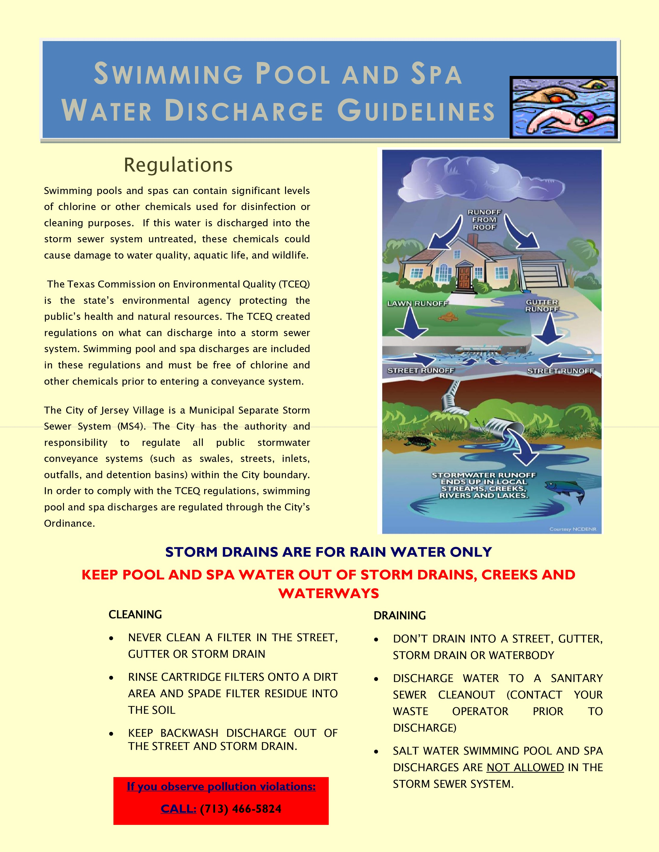

**Scan Me for More Information**